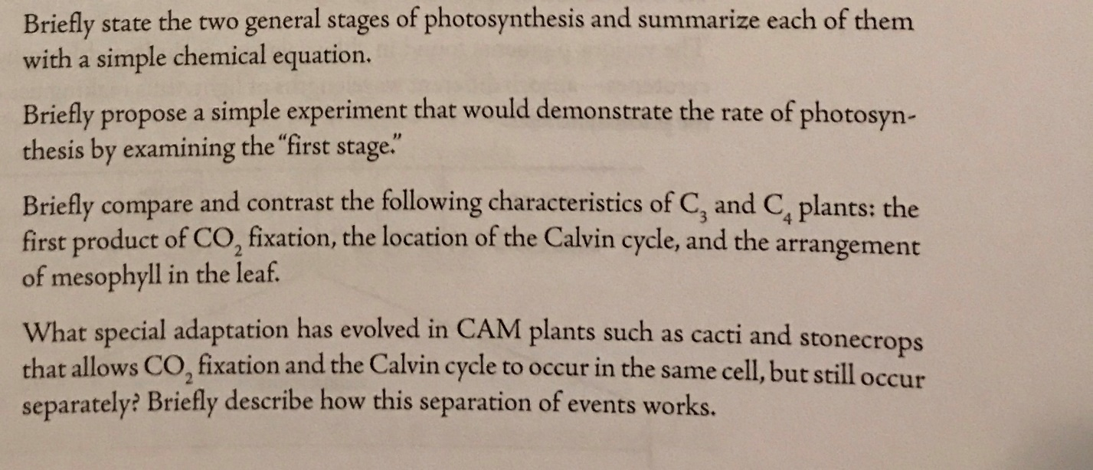
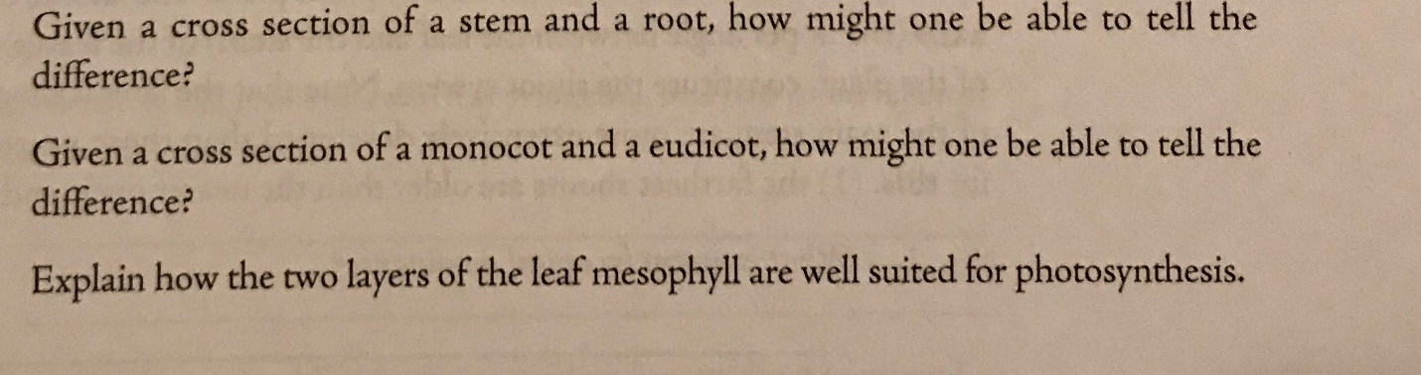
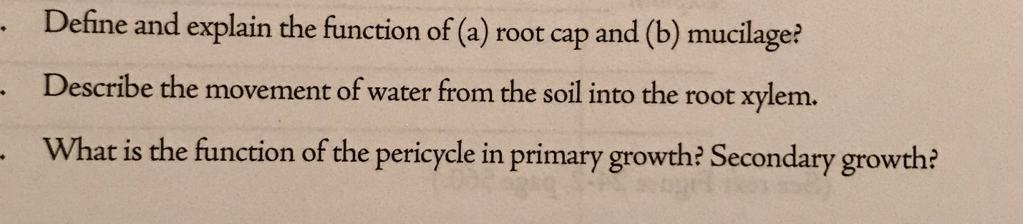
11. describe the function of the following : root, stem, leaf?
12. what are the three tissue systems of a plant and what are their function ?
13. how do simple tissues differ from complex tissues?give example of each.
14. what do sclereids,fibers, tracheids, and vessel elements have in common, compared to parenchyma, collenchyma, and sieve tube elements?

